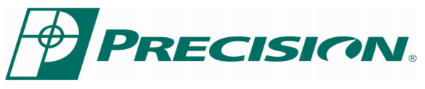
Vent Glass Setting Tape Installation (GST 001, GST 002)
Before You Begin - There are two styles of vent window glass/frame assembly, and you will need to determine which style you have before starting the installation of the New Setting Tape.
Style: A which does not include a hole (In the Glass) for the locking handle, and Style: B which does. Because of this difference there is an extra step that must be taken to properly and completely install the Setting Tape to the Style: A assembly.
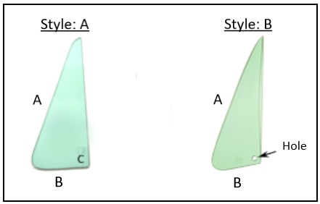
First Step - Style: A and Style: B Take one piece of Setting Tape and fold the narrow edge over the glass (Figure:1) as you run it the length of Side A and Side B (Above Image) place pieces of Electrical tape along the Setting Tape (Figure: 2) to help hold everything in place. (Electrical Tape works very well because it will not show after being trimmed)
Second Step - Style: A (Only) As you run the Setting Tape down Side B you will need to stop short (the width of the Setting Tape) of the corner, and cut it as straight as possible. Then you will take the remaining length of that piece and fold it (lengthwise) placing it on corner C (Figure: 3). This allows for complete glass coverage under the end of the frame that the handle mounts to (Figure: 4) .
(Tip: Place an Extra piece of Electrical Tape covering the edge were the two pieces of Setting Tape meet. (Figure: 3) This will help hold the edge piece in place as you install the glass frame.)
Final Step - Style: A and Style: B Now you will need to install the frame onto the glass. Using a mallet to gently tap the frame onto the glass, work the frame slowly and evenly until it is completely seated onto the glass. This will lock the Setting Tape between the glass and frame.
(Tip: Start by seating the center corner of the frame first, this will help keep the Setting Tape tight. Then work your way up Side A and B holding pressure on the frame to prevent it from walking back up off of the glass. Also: While doing this step place the glass edge on a soft but sturdy surface to prevent brakeage.)
Once the frame is completely seated, trim the Setting Tape with a sharp blade leaving a nice clean sealed vent glass assembly.
